Uber Fare Prediction Project Documentation

Table of Contents
S.No | Contents
1 | Aim
2 | Raw Data
2.1 | Dataset Columns
3 | Independent and Dependent Variables
4 | Steps Carried Out
5 | Functions Used
6 | Core Training Code
7 | Code Explanation
7.1 | Pandas (pd)
7.2 | NumPy (np)
7.3 | Matplotlib (plt)
7.4 | Haversine Function
7.5 | train_test_split()
7.6 | Linear Regression
7.7 | Mean Absolute Error (MAE)
7.8 | Mean Squared Error (MSE)
7.9 | Root Mean Squared Error (RMSE)
7.10 | R² Score (Coefficient of Determination)
8 | Visualized Projection of Best Fit Line
8.1 | Regression Line
8.2 | Scatter Plot
9 | Pickle Code
10 | Streamlit Application
10.1 | Running the Streamlit Application
10.2 | Streamlit Web Page
11 | Results
12 | Conclusion
13 | Future Scope
14 | References

1. Aim
The objective of this project is to predict the fare of an Uber ride based on the travel distance. A Simple Linear Regression model is trained using historical Uber trip data. After training, the model is saved using Pickle and deployed as a web application using Streamlit, allowing users to enter a travel distance and receive an estimated fare prediction.
2.Raw data :
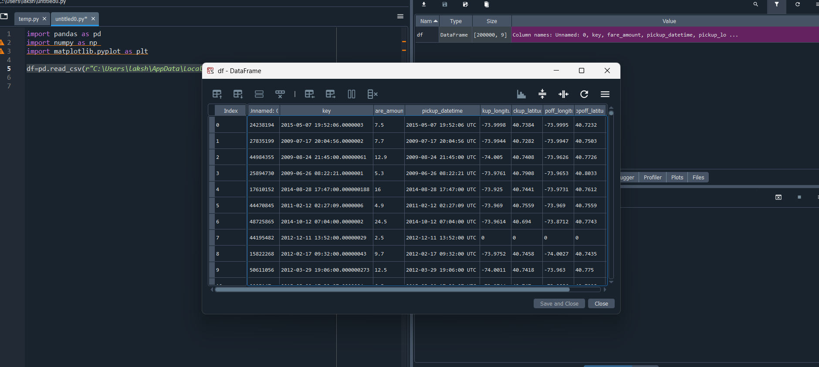
Columns:
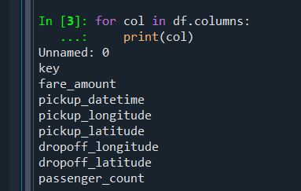

3. Independent and Dependent Variables
Independent Variable (X): distance_km
Dependent Variable (y): fare_amount

4. Steps Carried Out
1. Downloaded Uber dataset from Kaggle.
2. Loaded dataset into a pandas DataFrame.
3. Removed the Unnamed: 0 column.
4. Checked and removed null values.
5. Removed invalid passenger_count values (<=0).
6. Verified there were no negative fares.
7. Created distance_km using the Haversine formula.
8. Removed zero-distance trips.
9. Detected and removed unrealistic outliers (>70 km).
10. Prepared X and y.
11. Split data into train and test sets.
12. Trained a Simple Linear Regression model.
13. Evaluated with MAE, MSE, RMSE and R².
14. Saved model using Pickle.
15. Built a Streamlit application.

5.Functions Used
pd.read_csv(), drop(), dropna(), describe(), train_test_split(), LinearRegression(), fit(), predict(), mean_absolute_error(), mean_squared_error(), r2_score(), pickle.dump(), pickle.load(), st.number_input(), st.button(), st.success()

6.Core Training Code
x=df[['distance_km']].values
y=df['fare_amount'].values
X_train,X_test,y_train,y_test=train_test_split(x,y,test_size=0.2,random_state=0)
regressor=LinearRegression()
regressor.fit(X_train,y_train)
y_pred=regressor.predict(X_test)
import pandas as pd
import numpy as np
import matplotlib.pyplot as plt

df=pd.read_csv(r"D:\Cirrus\ml\uber.csv")

df.drop(columns=['Unnamed: 0'],inplace=True)

print(df.columns)
print(df.isna().sum())

df=df.head(1000)

print(df[df['fare_amount']<=0].shape)

print(df[df['passenger_count']<=0].shape)

print(df[['pickup_longitude','pickup_latitude','dropoff_longitude','dropoff_latitude']].describe())

df= df[df['passenger_count'] >0]

defhaversine(lat1, lon1, lat2, lon2):
R =6371 # Earth radius in kilometers

lat1 = np.radians(lat1)
lon1 = np.radians(lon1)
lat2 = np.radians(lat2)
lon2 = np.radians(lon2)

dlat = lat2 - lat1
dlon = lon2 - lon1

a = (np.sin(dlat /2) **2+
np.cos(lat1) * np.cos(lat2) *
np.sin(dlon /2) **2)

c =2* np.arcsin(np.sqrt(a))

return R * c

#creating a new column
df['distance_km'] =haversine(
df['pickup_latitude'],
df['pickup_longitude'],
df['dropoff_latitude'],
df['dropoff_longitude']
)

print(df[["distance_km","fare_amount"]].head())

print(df)

print(df[df["distance_km"]<=0].shape)

df = df[df['distance_km'] >0]

print(df['distance_km'].describe())

df = df[df['distance_km'] <=70]

df = df[df['distance_km'] >=0.1]

##building the model

x=df[["distance_km"]].values
y=df["fare_amount"].values

from sklearn.model_selection import train_test_split
x_train,x_test,y_train,y_test=train_test_split(x,y,test_size=0.2,random_state=0)

from sklearn.linear_model import LinearRegression
regressor=LinearRegression()
regressor.fit(x_train,y_train)

y_pred=regressor.predict(x_test)

plt.scatter(x_test,y_test,color="blue")
plt.plot(x_train,regressor.predict(x_train),color="red")
plt.title("distance_km vs fare_price")
plt.xlabel("distance_km")
plt.ylabel("fare_price")
plt.show()

from sklearn.metrics import mean_absolute_error,mean_squared_error
mae=mean_absolute_error(y_test,y_pred)
print(mae)

mse=mean_squared_error(y_test,y_pred)
print(mse)

rmse=np.sqrt(mse)
print(rmse)

from sklearn.metrics import r2_score

print("R² Score:",r2_score(y_test, y_pred))

7.Code explanation:

1. Pandas (pd)
Pandas is a Python library used for data manipulation and analysis. It helps us read datasets from files like CSV and Excel into DataFrames. It provides functions to clean data by handling missing values, removing unwanted columns, filtering records, and creating new features. In this project, Pandas is used to load the Uber dataset, remove unnecessary columns, filter invalid records, and create the distance_km column. It makes data preprocessing simple and efficient

2. NumPy (np)
NumPy is a numerical computing library used for performing fast mathematical operations on arrays. It provides built-in functions for trigonometric, statistical, and linear algebra calculations. In this project, NumPy is used to convert latitude and longitude values from degrees to radians and calculate the Haversine distance using functions like sin(), cos(), sqrt(), and arcsin(). It is also used to calculate the RMSE by taking the square root of the MSE.

3. Matplotlib (plt)
Matplotlib is a data visualization library used to create graphs and charts. It helps us understand trends, patterns, and relationships within the data. In this project, it is used to plot a scatter graph of the actual Uber fare against the travel distance and draw the regression line predicted by the Linear Regression model. This visualization helps us evaluate how well the model fits the data.

4. Haversine Function
The Haversine function is used to calculate the shortest distance between two locations on the Earth's surface using their latitude and longitude coordinates. Since the Earth is spherical, this formula provides a more accurate distance than a simple straight-line calculation. In this project, it converts the pickup and drop-off GPS coordinates into a new feature called distance_km. This distance becomes the input feature for predicting the Uber fare.

5. train_test_split()
The train_test_split() function is used to divide the dataset into training and testing sets. The training data is used to teach the machine learning model, while the testing data is used to evaluate its performance on unseen data. In this project, 80% of the data is used for training and 20% for testing. The random_state parameter ensures that the split remains the same every time the code is executed, making the results reproducible.

6. Linear Regression
Linear Regression is a supervised machine learning algorithm used to predict continuous numerical values. It learns the relationship between an independent variable and a dependent variable by fitting the best possible straight line through the data. In this project, the model learns how the travel distance affects the Uber fare. Once trained, it predicts the fare amount for new distances.

7. MAE (Mean Absolute Error)
Mean Absolute Error (MAE) measures the average absolute difference between the actual values and the predicted values. It tells us, on average, how much the model's predictions differ from the true values without considering the direction of the error. Since the errors are not squared, every mistake contributes equally. A lower MAE indicates better model accuracy.

8. MSE (Mean Squared Error)
Mean Squared Error (MSE) measures the average of the squared differences between the actual and predicted values. Squaring the errors gives more importance to larger prediction mistakes, making MSE sensitive to outliers. It is widely used to evaluate regression models during training. A lower MSE indicates that the model is making fewer and smaller errors.

9. RMSE (Root Mean Squared Error)
Root Mean Squared Error (RMSE) is the square root of the Mean Squared Error. It represents the average prediction error in the same unit as the target variable, making it easier to interpret than MSE. RMSE penalizes larger errors more than smaller ones because it is based on squared errors. A lower RMSE indicates better predictive performance.

10. R² Score (Coefficient of Determination)
The R² Score measures how well the regression model explains the variation in the target variable. Its value ranges from negative values up to 1, where 1 indicates a perfect fit and 0 means the model performs no better than predicting the average target value. Higher R² values indicate that the model explains a greater proportion of the data's variability. It is one of the most commonly used metrics for evaluating regression models.

8.the visualized projection of best fit line :

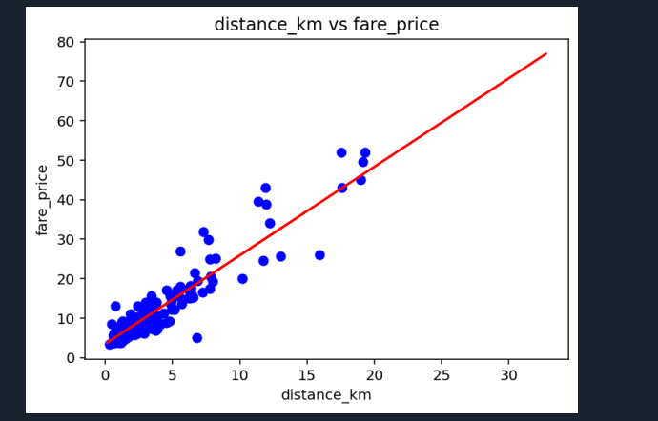

Regression Line
The regression line is the best-fit straight line generated by the Linear Regression algorithm. It represents the predicted relationship between the input feature (distance) and the target variable (fare). The line is calculated by minimizing the prediction errors between the actual and predicted values. It is used to estimate the fare for any new travel distance.

Scatter Plot
A scatter plot is a graph that displays the relationship between two numerical variables using individual data points. In this project, the x-axis represents the travel distance, and the y-axis represents the Uber fare amount. It helps visualize whether a linear relationship exists between distance and fare. The closer the points are to the regression line, the better the model fits the data.

9.Pickle Code
import pickle
with open('uber_fare.pkl','wb') as file:
pickle.dump(regressor,file)
with open('uber_fare.pkl','rb') as file:
model=pickle.load(file)

import pickle

withopen("uber_fare.pkl","wb") asfile:
pickle.dump(regressor,file)

print("Model saved successfully!")

Streamlit Code
import streamlit as st
import pickle
with open('uber_fare.pkl','rb') as file:
model=pickle.load(file)
distance=st.number_input('Enter Distance (km)',min_value=0.1)
if st.button('Predict Fare'):
prediction=model.predict([[distance]])
st.success(f'Estimated Fare: {prediction[0]:.2f}')
import streamlit as st
import pickle
import numpy as np

# Page Configuration
st.set_page_config(
page_title="Uber Fare Prediction",
page_icon="🚖",
layout="centered"
)

# Load Model
withopen("uber_fare.pkl","rb") asfile:
model = pickle.load(file)

# Title
st.title("🚖 Uber Fare Prediction")

st.write("Predict the Uber fare based on the distance travelled.")

st.divider()

# User Input
distance = st.number_input(
"Enter Distance (km)",
min_value=0.1,
max_value=70.0,
value=1.0,
step=0.1
)

# Prediction
if st.button("Predict Fare"):

prediction = model.predict([[distance]])

fare = prediction[0]

st.success(f"Estimated Fare: ₹{fare:.2f}")

st.divider()

st.write("### Model Information")

st.write("- Model : Simple Linear Regression")
st.write("- Feature : Distance (km)")
st.write("- Target : Uber Fare")
st.write("- R² Score : 0.875")

run in terminal: streamlit run fare.py
when you run this in terminal:
streamlit run fare.py
Streamlit:
- ✅ Starts a local web server on your computer.
- ✅ Executes your fare.py script.
- ✅ Converts all st.* commands into web page elements.
- ✅Opens your browser at:
Local URL: http://localhost:8501
Network URL: http://192.168.29.33:8501

10.The web page is created :
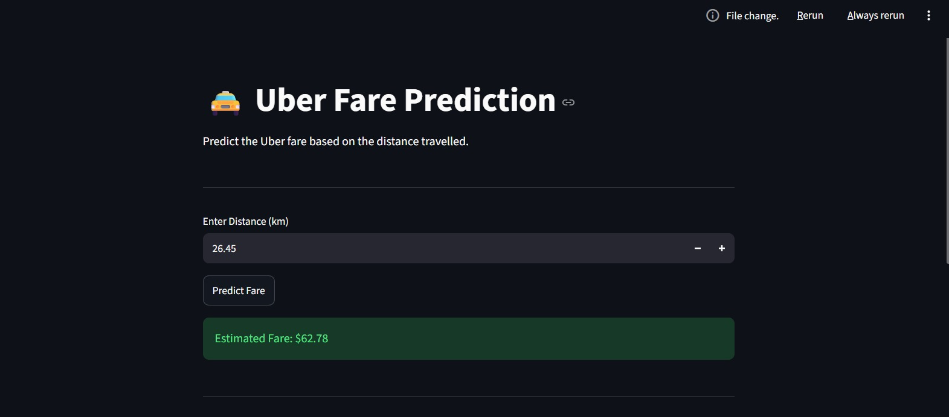
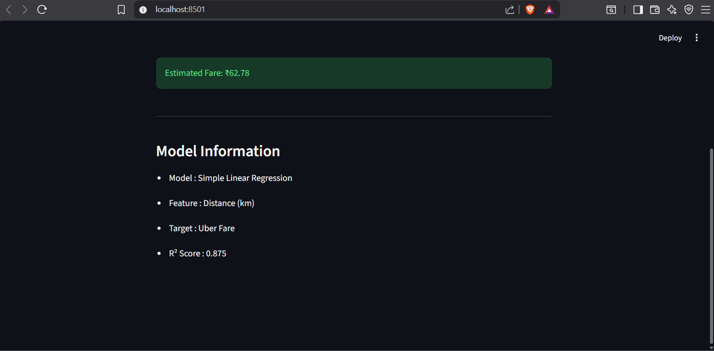

11.Results
MAE = 2.0877
RMSE = 3.2236
R² = 0.8749

12.Conclusion
This project demonstrates the complete machine learning workflow:
- Collecting data
- Cleaning and preprocessing data
- Creating new features using the Haversine formula
- Removing invalid records and outliers
- Training a Simple Linear Regression model
- Evaluating model performance
- Saving the trained model with Pickle
- Deploying the model using Streamlit for real-time fare prediction
The model achieves an R² score of 0.8749, indicating that trip distance is a strong predictor of Uber fare and making the project a solid baseline regression solution.

13.Future Scope
- Multiple Linear Regression
- Decision Tree
- Random Forest
- XGBoost
- Gradient Boosting
- Add pickup hour/day/month and passenger count
- Hyperparameter tuning
- Deploy on Streamlit Cloud

14.References
- Uber Fare Dataset (Kaggle)
- Pandas Documentation
- NumPy Documentation
- Matplotlib Documentation
- Scikit-learn Documentation
- Streamlit Documentation
- Python Pickle Documentation

